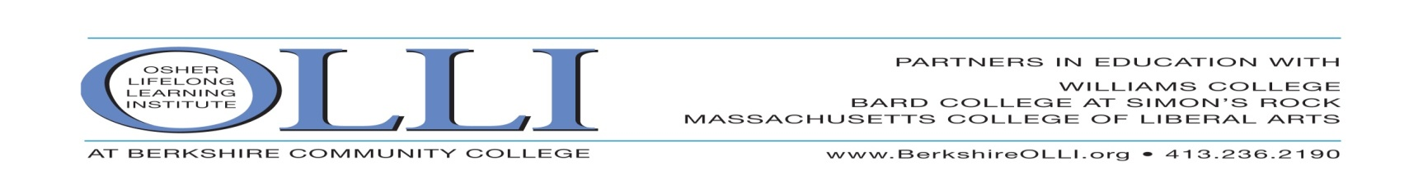
FLORIDA WEST COAST OLLI EVENT!
Wednesday, March 8, 2017 10:30am
MOTE MARINE LABORATORY & AQUARIUM
Guided Tour & Lunch
Just North of St. Armand’s Circle, Long Boat Key; 1600 Ken Thompson Parkway, Sarasota, FL 34236
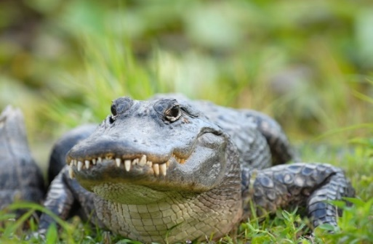
featuring
THE TEETH BENEATH: The Wild World
of Gators, Crocs and Caimans
Can you tell a gator from a caiman from a croc?
Think reptiles are quiet critters?
What happens when humans and gators meet?
Special Guide Extraordinaire: Morty Kallman
Event Leader: Turbi Smilow: 413.822.6825 Special Event Chair: Arline Breskin 413.446.4102
Register online at BerkshireOLLI.org, clip & mail to OLLI at BCC, 1350 West Street, Pittsfield, MA 01201
or call 413.236.2190 to register. DEADLINE February 27th.
____________________________________________________________________________________
MOTE AQUARIUM VISIT, Wednesday, March 8, 2017 RESERVE BY FEB. 27TH
Name(s):_______________________________________________ Cell Phone:______________
Check Lunch Choice: Chicken salad sandwich Veggie wrap Turkey & Swiss
_______ OLLI member(s) @ $30.00 $__________
_____ Non-OLLI Member Guest @ $35 each $__________
GRAND TOTAL $__________
Payment Options: Check Visa Master Card Discover Card American Express
Credit Card #: _________________________ Expiration Date (mm-yy)_______ Security code:_______
Print name as appears on card: ___________________________________________________
Billing Address of Card:__________________________________________________________
Signature: __________________________________________________

