

The OLLI SPECIAL EVENTS COMMITTEE presents an evening at
JACOB’S PILLOW
Thursday, June 22, 2017
featuring the MIAMI CITY BALLET
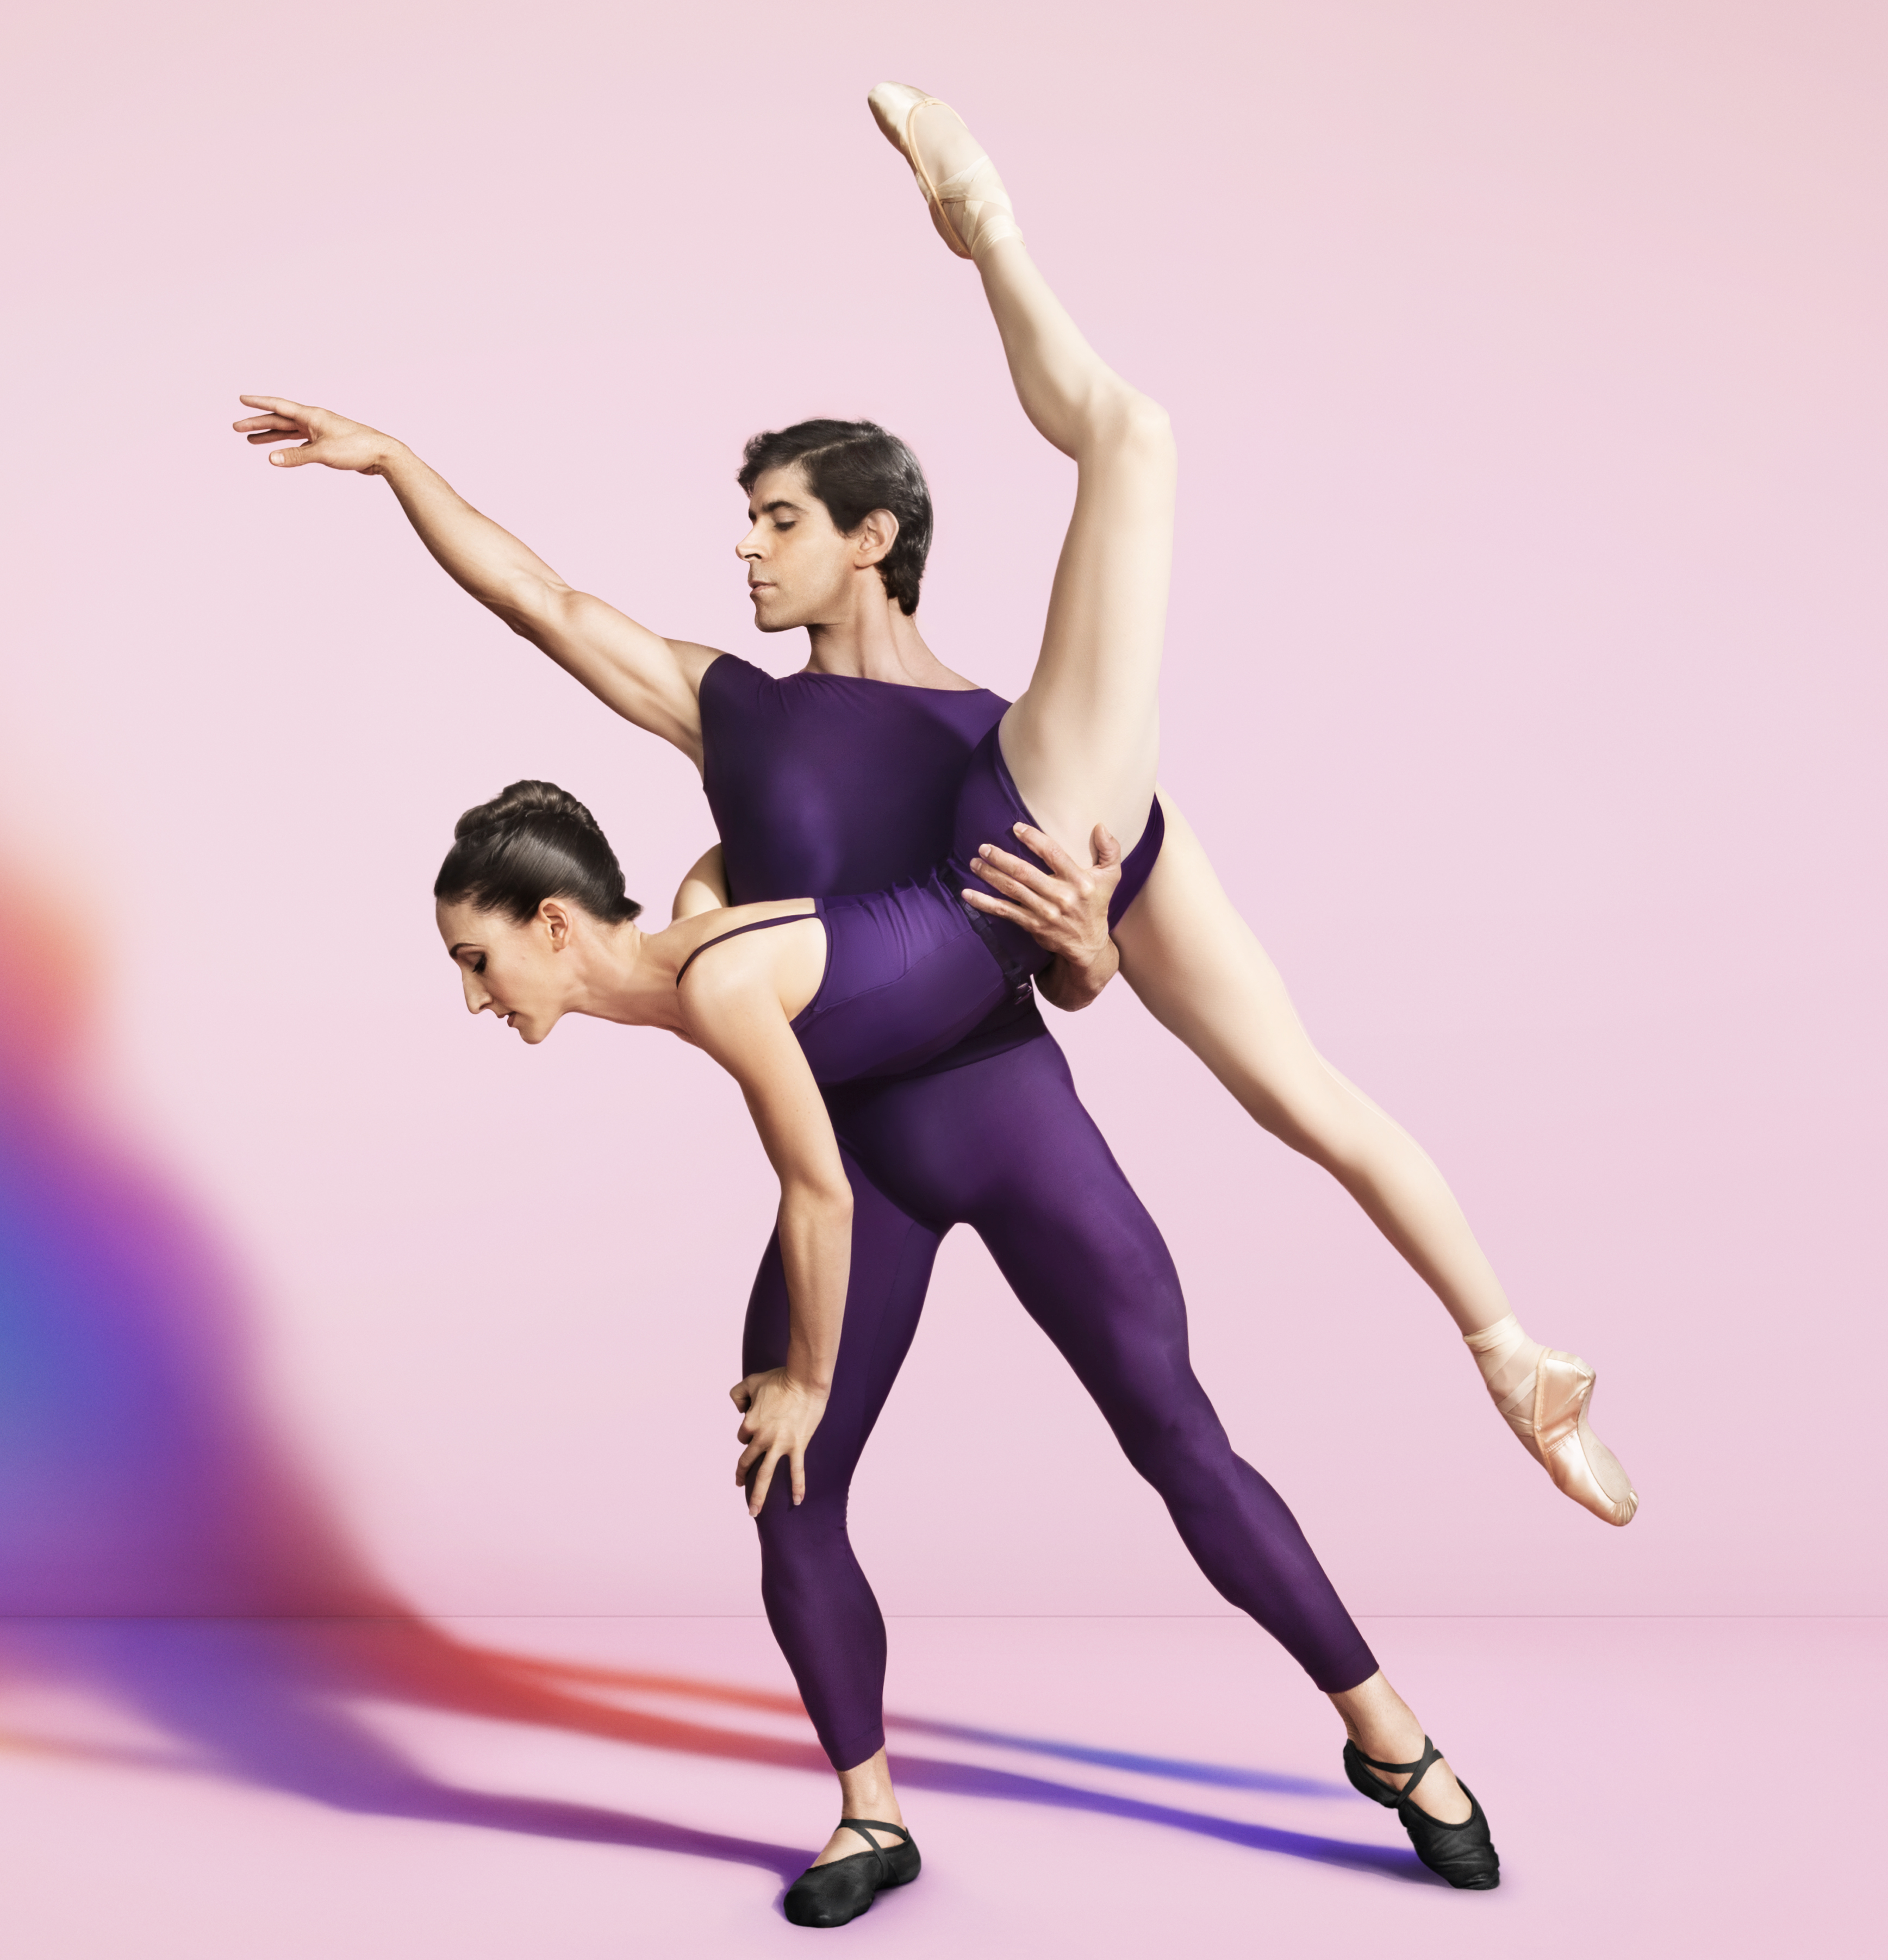
Described as “bold, light, immediate, intensely musical” (The New York Times), Miami City Ballet makes its first Festival appearance since 1998. Works on the program exhibit the company’s wide range and prowess, including master choreographer George Balanchine’s challenging and technically precise Allegro Brillante set to Peter Ilyitch Tchaikovsky’s energetic “Third Piano Concerto No. 3”. The program also includes Tony Award-winning choreographer Christopher Wheeldon’s elegant Polyphonia, danced to György Ligeti’s complex and eerily melodious score, and Peter Martin’s elegant Barber Violin Concerto.
NORTON OWEN, Preservation Director, will give a talk in Blake’s Barn - 5:15 pm

BRING A PICNIC SUPPER – OUR OLLI CHEFS WILL PROVIDE DESSERTS & ICED TEA

Talk at 5:15 – Supper at 6:00 – Dessert at 6:30 – Performance at 8pm
Please return your reservation immediately so we can order the correct number of tickets.
Seating in the order received. Refunds only if space filled from a waiting list.
Event Leaders: Lesley Oransky 914.261.6037 Ellen Tabs 413.274.3434
Special Event Chair: Arline Breskin 413.243.3640

______________Clip & Mail to OLLI, at BCC., 1350 West Street, Pittsfield, MA 01201 or FAX: 413.443.1797_______________
JACOB’S PILLOW June 22, 2017 Name:_____________________________________________ Phone:______________

Registration OLLI members_______places at $78.00…………………...………..$________
Guests____________ $84..00…………………………....$________
Dessert only with your own subscription_______ 8.00…………………..…………$________
TOTAL……………………........$________
Payment Options
Check ◻ Visa ◻ Master Card ◻ Discover Card ◻ American Express ◻
Credit Card #: ____________________________ Exp: Date(mm-yy)_________Security code:_______
Name as it appears on card:_______________________________________________________________
Billing address of card:__________________________________________________________________
Signature:___________________________________________________________________________

