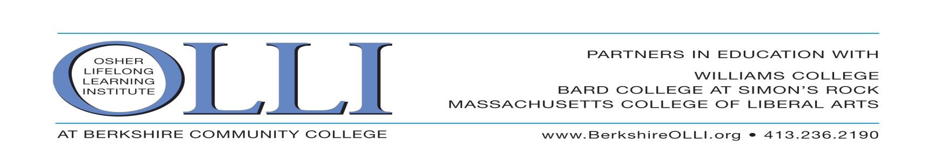
The OLLI SPECIAL EVENTS COMMITTEE presents
Behind the Scenes at the
BERKSHIRE CAROUSEL
Wednesday, May 31, 2017 10:30 AM

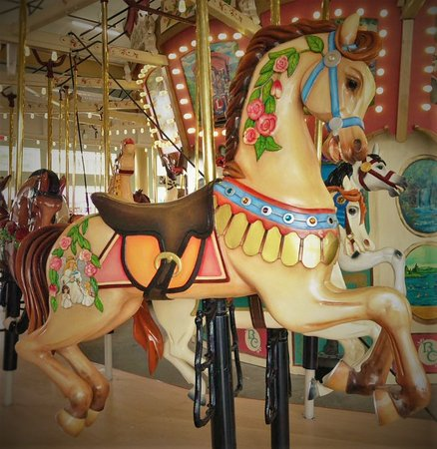
Built and carved by volunteers over 7 years, the Berkshire Carousel is the largest community art project in western Massachusetts! We will explore the carving studio, splash some paint on new horses, and gain understanding of the detailed work involved in producing the Berkshire Carousel. The beauty and craftsmanship rival those of historic carousels. The figures are modeled after those of the most famous carvers of the Golden Age of Carousels from 1880 to 1930. Three chariots have been constructed, and Berkshire residents have completed the artwork for the Berkshire scenes to be used in the 14 rounding boards in the main frame top.
Tour the Workshop & the Carousel Hear the History of the Horses
+ Lunch by OLLI Chefs!

Refunds only if space filled from a waiting list. Event Leader: Bonnie Desrosiers 413.442.5490

______________Clip & Mail to OLLI, at BCC., 1350 West Street, Pittsfield, MA 01201 _______________
CAROUSEL May 31, 2017 Name:_____________________________________________Phone:______________

Registration: OLLI Members_______places at $32.00…………………...………$________
Guests ________places at $40.00……………………………$________
TOTAL……….…………….......$________

Payment Options
Check Visa Master Card Discover Card American Express
Credit Card #: ____________________________ Exp: Date (mm-yy)_________Security code:______
Print name as appears on card:__________________________________________________________
Billing Address of Card:_______________________________________________________________
Signature:________________________________________________________________________

