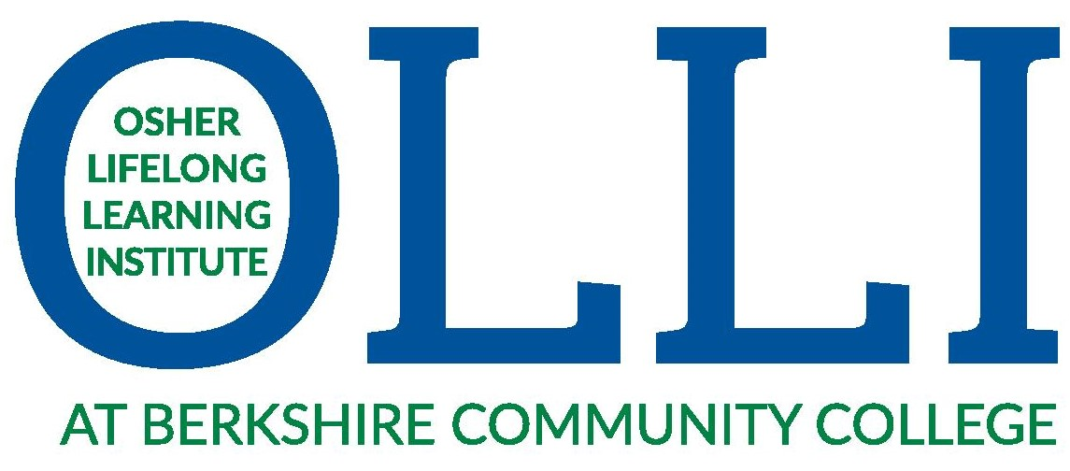Scholarship Request

An OLLI membership introduces you to a vibrant community of adults fifty and better eager to learn for the love of it, share ideas with fellow students, and forge new friendships with like-minded people. And no grades or tests!
A hallmark of OLLI at Berkshire Community College is ensuring that participation is open to all adults eager to learn for the joy of learning. To facilitate that effort, we are pleased to offer a Scholarship Program to those with financial need. For $25 per year, the scholarship offers two free courses per semester, full access to our members-only events and Shared Interest Groups, and discounted admission to our University Days, Distinguished Speaker Series and Special Events.
To apply, please fill out the below & our Executive Director will contact you:
Please email to olli@berkshirecc.edu or mail to OLLI at BCC, 1350 West Street, Pittsfield MA 01201
Name: ________________________________ Phone: _______________

Address: _______________________ City: _________________ State: ____

Zipcode: _______ Email:_________________________________________
Please provide a brief explanation in support of this application:

In addition, OLLI participates in the Card to Culture program. This is open to anyone with a WIC, EBT or ConnectorCare card, and includes the scholarship membership plus free admission to our Distinguished Speaker Series and University Day symposiums. Pre-registration is required, and please be prepared to show your card at the door. All household members on the card qualify for the program!
For more information, please visit berkshireolli.org or call 413-236-2190

Scholarships and the Card to Culture program are generously underwritten by the OLLI members, with in-kind support from Berkshire Community College

