Shakespeare Performed:
Courtyard Theatre’s King Lear with Sheep
By: Holly Dugan
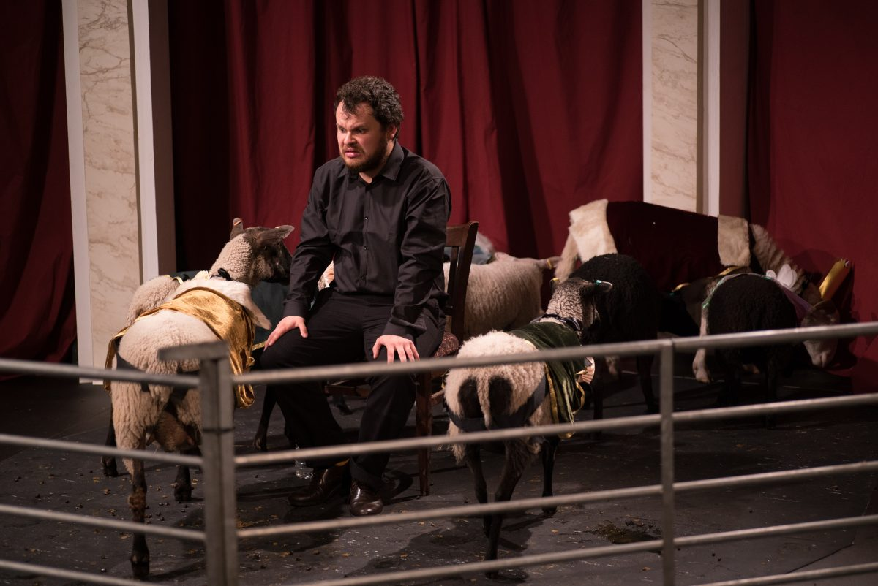
Missouri Williams’s King Lear with Sheep lives up to its title: it stages Shakespeare’s famous play with sheep. More specifically: Shetland, Blackface, and Oxford Down sheep from both urban and agricultural farms in England, who have played Lear in a wide variety of heaths. The play premiered in a former timber warehouse at Surrey Docks in East London in June 2014. It then moved to pastoral Sussex in July 2014, where it was staged in a hay barn on sheep and cattle breeder Stephen Carr’s farm in Jevington Place. In August 2015, it returned to London for a two-week revival at the Courtyard Theatre in Hoxton, where it gained national and international attention. (Above Photo Credit: Will Hazel.)
Why would anyone try to stage King Lear with sheep? Shakespeare and sheep seem incongruous. And this is perhaps part of its appeal. Reviewers have described it as both “odd and wondrous,” as well as just a one-man production of Lear “surrounded by pooping sheep” (Guardian and National Public Radio, respectively). As the program explains, the play reexamines its famous predecessor and seeks to “overturn theatrical conventions through the startling and revolutionary device of costumed sheep.” It mostly succeeds. The play sticks a hoof in our expectations of Shakespeare (though not necessarily in our expectations of sheep). Staging the chaos that ensues when “a stubborn director” tries to put on a production of the play cast with only sheep, the play is an ovine fiasco. And this is what we’re here to see.
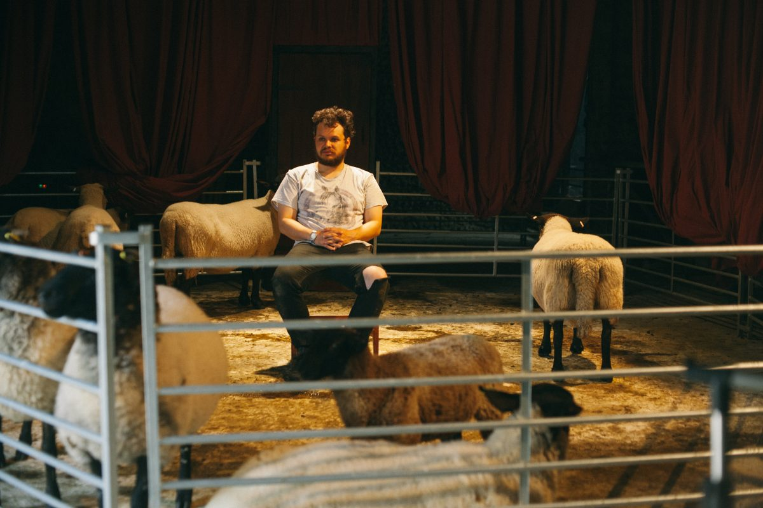
Photo Credit: Nick Morris
The play astutely frames itself within this desire, even as the sheep hit all their cues. A director, brilliantly played by Alasdair Saksena, opens the play with an extended ten-minute apology. In it, he anxiously explains that he doesn’t know what’s happened or why his actors haven’t taken their cues. He assures us that the sheep have been successfully performing Lear for months. He quotes positive reviews: “‘functional,’ according to Guardian; ‘apt,’ according to the Independent.” But, tonight, the sheep refuse to perform. His hypothesis is that Cordelia, “that bitch,” has been turning the sheep against him.
One way to understand this is the mad ramblings of a lunatic director, who fails to realize that his actors are animals. Referring to himself as a carpenter and the ovine actors as tools, the “director” emphasizes at length the shared, if unequal, labor of performance: “It’s like I’m a carpenter and they’re my tools and together we’re building a house . . . a play house . . . because it’s a play.” Saskena’s director is clearly stalling, a term that has multiple meanings in this play. He is acutely aware of economics: “You paid money. You want to be entertained.” And, of course, he’s right: after all, he’s sitting in a makeshift stall, with only an iconic red curtain and paper Doric columns to signal its status as a stage while we wait for the sheep to arrive.
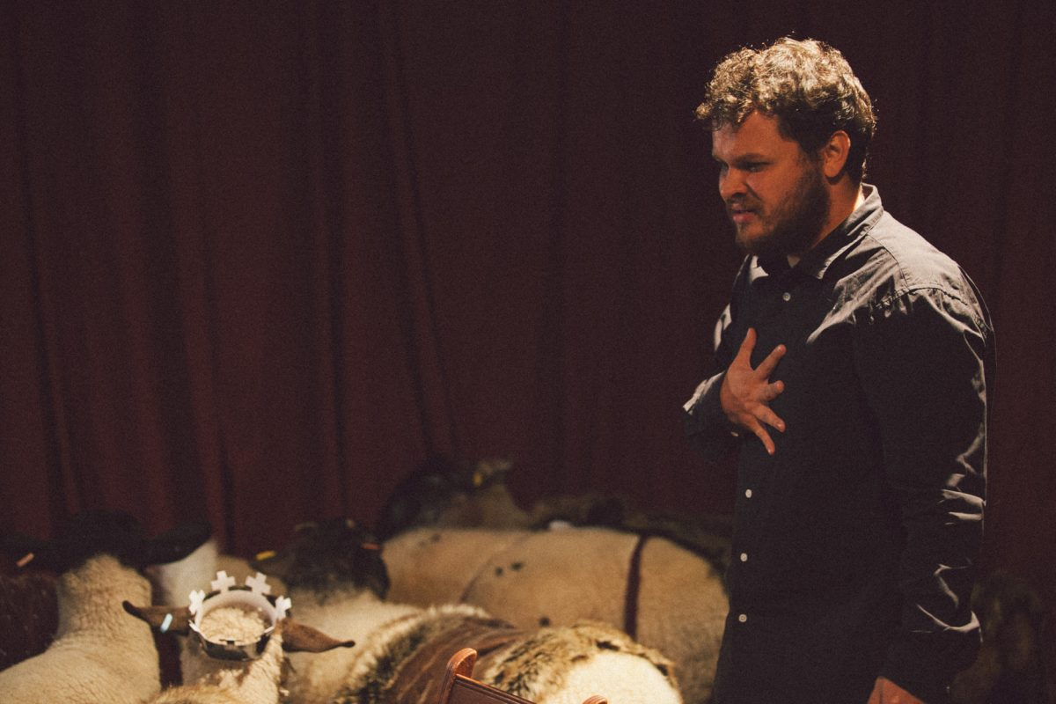
Photo Credit: Nick Morris
The conceit of the play—that the sheep’s refusal to perform is limited to this particular night—refracts Shakespeare’s play in peculiar and interesting ways. The director’s apology for the delayed performance of Lear only heightens our collective desire to see sheep. When they finally arrive, the director explodes with Lear-like fury, just as the audience erupts with delight. This disjuncture is heightened by the sensory shift in the theater. Though other reviewers have insisted that the entire theater smells of sheep from the start of the play, I disagree. I knew exactly when the sheep took their cues to enter: we smelled them and heard them before we saw them, their animal presence both the point of the play as well as its paradox.
Nine ewes entered, wearing paper hats as well as Elizabethan ruffs and capes. Because they’re sheep, we perceive them collectively as a flock. It’s hard to discern exactly who is playing what role until the director points them out to us. The largest, however, is Lear, wearing a paper crown. Lear is played by Hazel, a Whitefaced Woodland ewe, easily mistaken for a ram because of her horns. Though she is ultimately outstaged by Saskena’s Lear, the program emphasizes Hazel’s impressive and extensive background: she has appeared in Cinderella (Disney 2015) and The Apprentice (BBC 2015).
The smallest, Snowdrop, a Shetland lamb, is Cordelia. This is practical: as the play’s director Lucie Elven has explained in interviews, Cordelia is usually played by the smallest and most docile animal in the flock, since Saskena must be able to chase her down and pick her up during the performance. “So young and so untender” (1.1.118), Cordelia as lamb transforms Lear’s misogyny into something just as dark though perhaps a bit more ironic. Though these particular sheep work as performers and may escape ending up as food, most don’t. (The program notes for instance that Shetland sheep are known for their “sweet meat and superior wool.”)
The director’s frenetic attempt to satisfy audience desire leads him to perform the play himself, first by quoting Lear’s misogynist-inflected invectives to the ewes—“into her womb convey sterility” (1.4.292)—and then culminating in a one-man performance, complete with a half-naked tempest scene (staged with strobe lights), an eye-gouging scene that was more slapstick than grand Guignol by necessity, and a frenetic workout on the cliffs of Dover with the director’s mad Tom almost indistinguishable from his Lear. Saskena’s pace intensifies across the performance; this is Lear played at three times its normal speed. His cast-mates remain calm, eating, bleating, bucking, and shitting on stage around him until, finally, the climax: a sweet reunion, with the director cradling Cordelia in his arms as she nuzzles his hair.
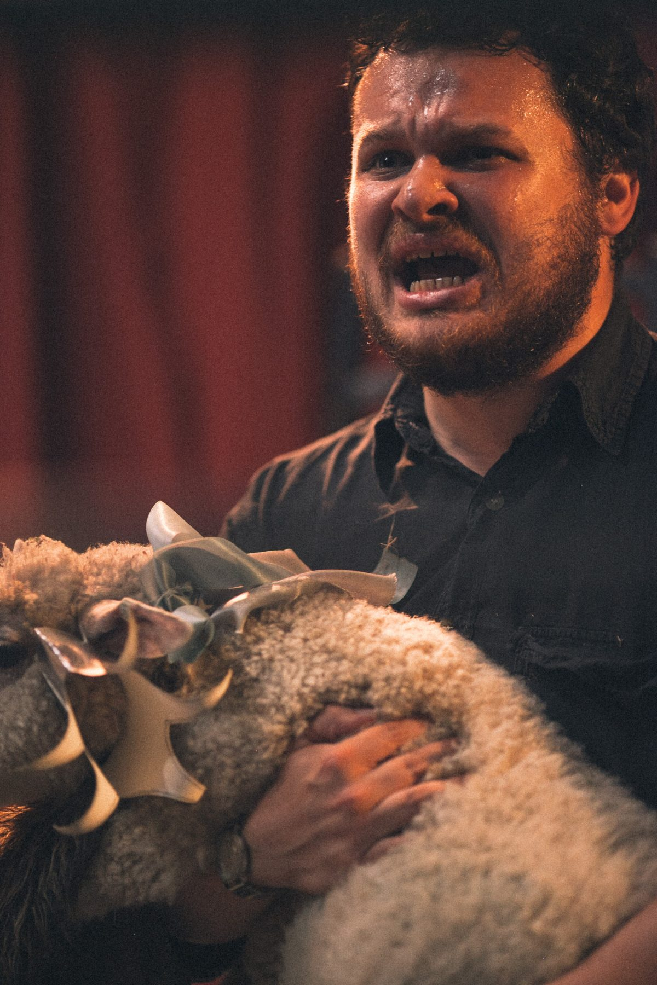
Photo Credit: Nick Morris
We ate it up: I’ve never heard an audience react more vocally to Lear’s misogyny or his grief about his daughter than when they were played by sheep. Lear’s hatred of Cordelia “that bitch” is reframed by its object. Snowdrop is quite literally not a bitch but a lamb. Because his cruelty fixates on such an overloaded symbol of innocence, it renders him both mad and comic. Likewise, the lamb as Cordelia is no longer just another sheep, one indistinguishable member of the collective noun. We care about Cordelia the lamb in ways we often don’t about Cordelia the woman.
That sympathy is both the strength and weakness of the play: King Lear with Sheep reveals the stunning misogyny at the heart of Shakespeare’s script. But it doesn’t provide insight into what it’s like to live within that world. In the end, Cordelia remains just as opaque in this play as she does in Shakespeare’s. As we leave, we pass signs that remind us of the dangers of staging Shakespeare among, near, and with animals, especially livestock. We are advised to wash our hands immediately.
Lear is no stranger to posthuman readings. As Laurie Shannon argues in The Accommodated Animal (2013), the play is “relentless,” voicing a “grim reckoning” of man’s place among the beasts. Likewise, Craig Dionne in Posthuman Lear suggests that the play’s trajectory from court to heath activates a different kind of language about our role in a “denuded” world. But King Lear with Sheep proves that even this bleak play can become an appealing, late summer farce if staged in the right conditions. And for this reason, Williams more than succeeds at this “farmyard meditation on the nature of performance” (The Independent). I left feeling uncomfortable about what I had consumed that day and pondering what my desire to see King Lear with Sheep and perhaps also my desire for a posthuman Shakespeare reveal about my own palate and the labor required to satisfy it.

Holly Dugan, “Shakespeare Performed: Courtyard Theatre’s King Lear with Sheep,” Shakespeare Quarterly, June 2017, http://shakespearequarterly.folger.edu/web_exclusive/shakespeare-performed-courtyard-theatres-king-lear-with-sheep/.

