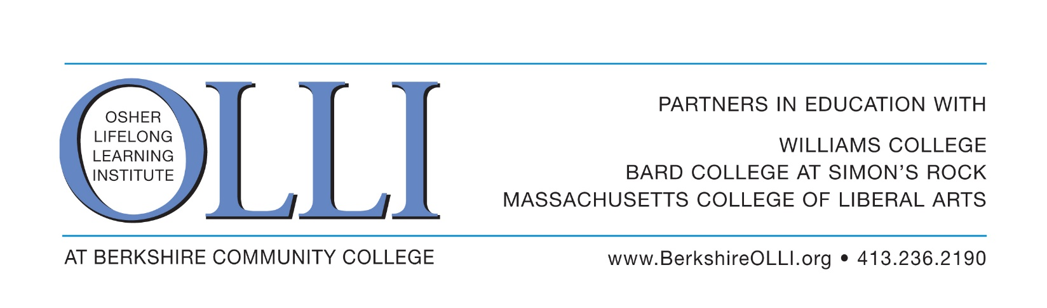
OLLI Leadership Academy
Application for Participation
June 10, 17 & 24 2019

About the OLLI Leadership Academy:
It is the intent of the OLLI Leadership Academy to train and prepare OLLI members who are interested in becoming active volunteer leaders with OLLI through committee and/or board membership. Academy participation is limited to 15 OLLI members.

The OLLI Leadership Academy consists of 3 half-day trainings on Mondays in June (June 10, 17 and 24) from 9:30 am to 1pm in at the Berkshire Community College. There is no cost to participate and lunch is included each week. The application deadline is Saturday, May 18th.

The Academy will include background on the Osher Lifelong Learning Institute at Berkshire Community College including vision, mission, strategic direction and finances. You will hear from OLLI and Berkshire County leaders on communications, philanthropy and more.

Your Information:

Name:

Address: ___ City: State: _ ZipCode:

Home Phone: Mobile Phone:

Email Address:

Why are you interested in this Leadership Academy?

Is there a particular role you’d like to take in OLLI at BCC?

OLLI Leadership Academy
Application for Participation
Page Two

Current/Prior professional work or occupation ___________________________________________

Current/Prior board experience:

Current/Prior volunteer experience:

Do you have any special skills about which we should be aware? Yes No

If yes, please explain

Is there anything in particular you would like to learn about, regarding non-profit organizations, OLLI, or lifelong learning, during the OLLI Leadership Academy? If so, please explain…

Are you available for all three trainings during the Leadership Academy? They are Mondays, June 10, 17 and 24, from 9:30am to 1pm at Berkshire Community College. There is no cost to participate and lunch will be provided each week. Yes ___ No

The application deadline is Saturday, May 11th. Applicants who are not selected for this year’s Leadership Academy will be considered for the next one. Please mail or deliver your application to:

OLLI at BCC
Berkshire Community College
1350 West Street
Pittsfield, MA 01201

or email your application as an attachment to: OLLI@berkshirecc.edu. You may also fax it to 413-443-1797.

Questions? Call OLLI Executive Director Megan Whilden at 413-236-2192.

